Reports And Dashboard

Step 1:- Created a Custom Report Type For report Opportunities With Work Order Closed Won

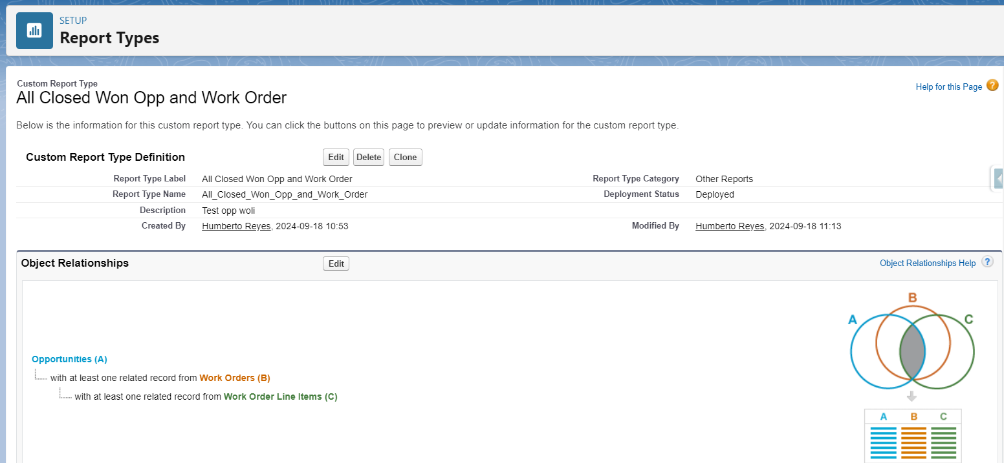

Step 2:- Created Report For the Opportunities With Work Order Closed Won

Report Name:- Opportunities With Work Order Closed Won

https://hantverksdataab.lightning.force.com/lightning/r/Report/00OQu000003N3hpMAC/view

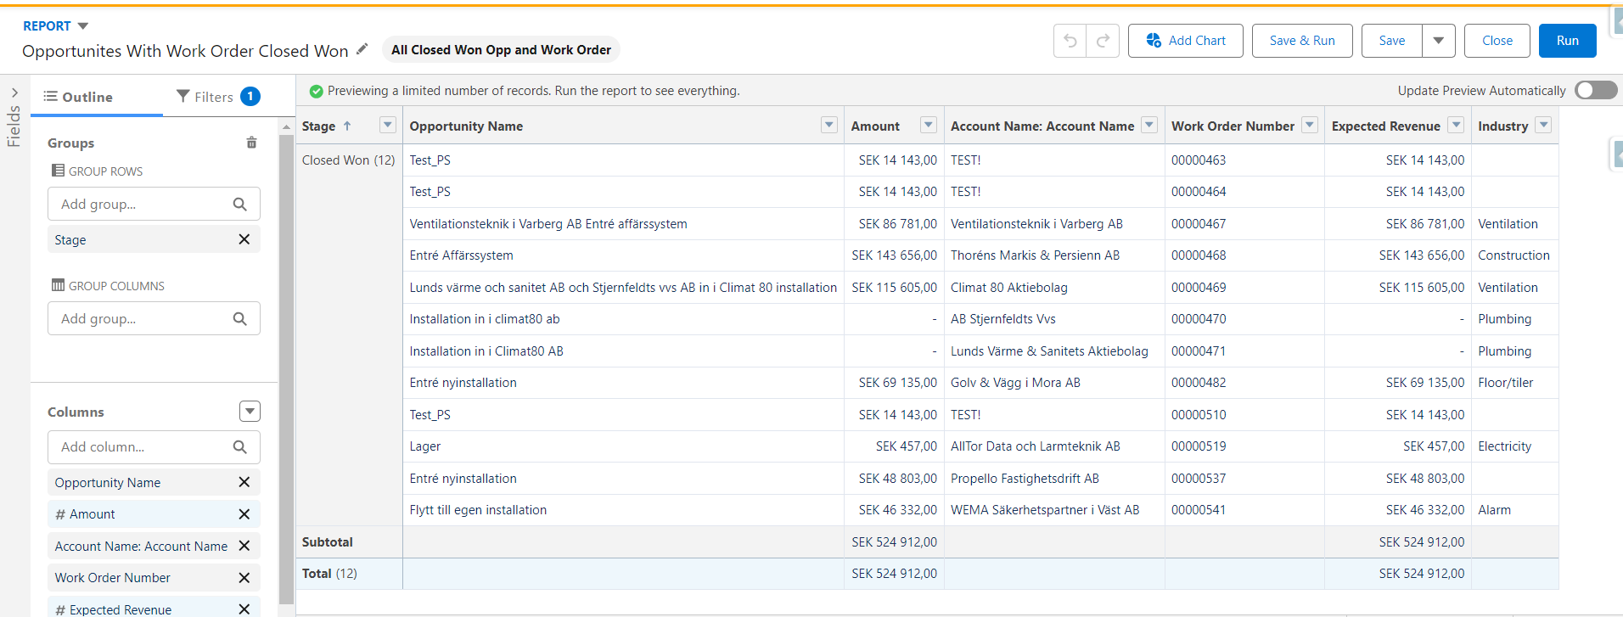

Step 3:- Created Custom Report Type Work Order And Work Order Line Items
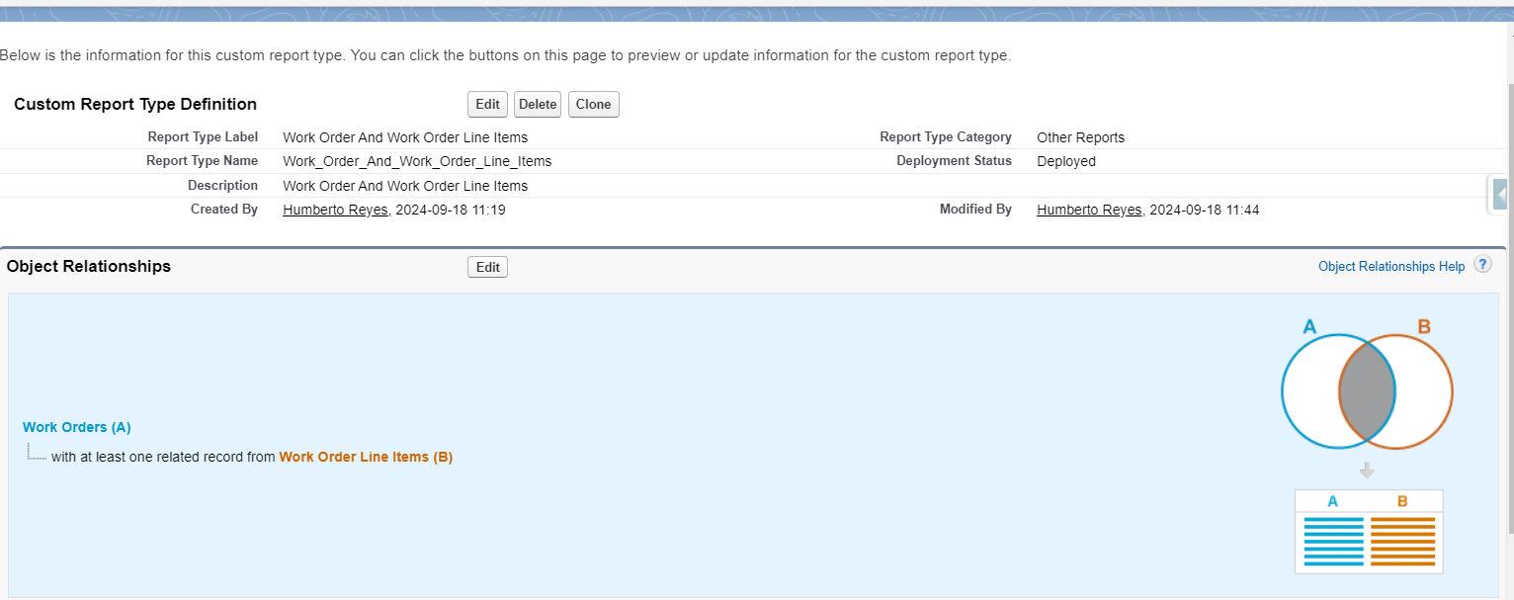

Step 4:- Created Report Of Work Order and Work order line item

Report Name :- Work Order and Work order line item

https://hantverksdataab.lightning.force.com/lightning/r/Report/00OQu000003N2AgMAK/view
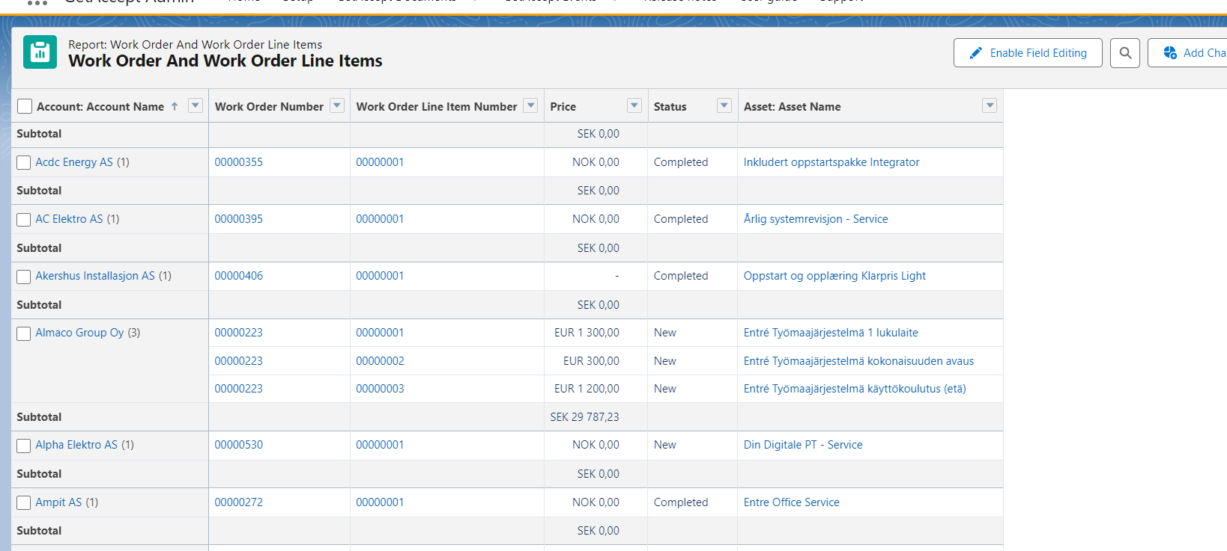

Step 5 :- Created a Dashboard Training Dashboard
Dashboard link :-
https://hantverksdataab.lightning.force.com/lightning/r/Dashboard/01ZQu0000079Y9hMAE/view?queryScope=userFolders
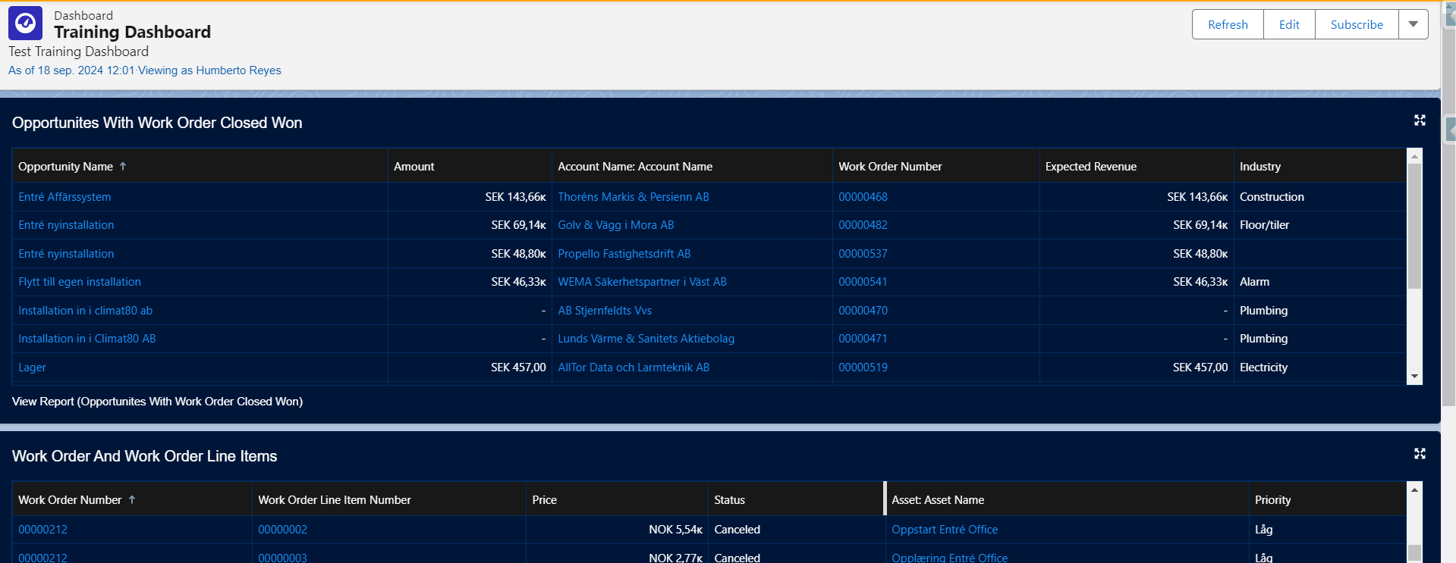
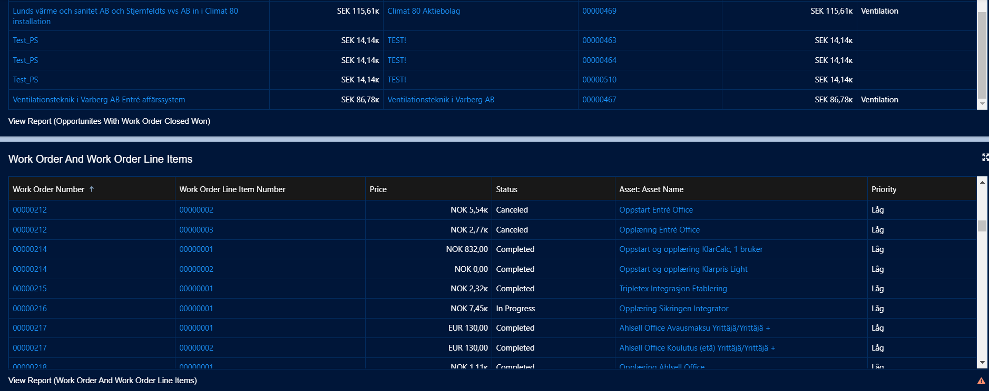

Note:-
1)The first report shows a list of closed won opportunities with corresponding work order numbers and amounts.
2)The second report details work orders and associated line items, including price, status, asset names, and priorities.
3)You Need to navigate to the report and dashboard tab to view the report and dashboard.
Links:-
1) Håndverksdata Sales
https://hantverksdataab.lightning.force.com/lightning/page/home
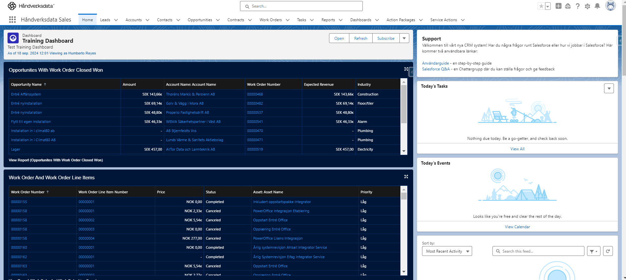
2) KlarPris Sales
https://hantverksdataab.lightning.force.com/lightning/page/home
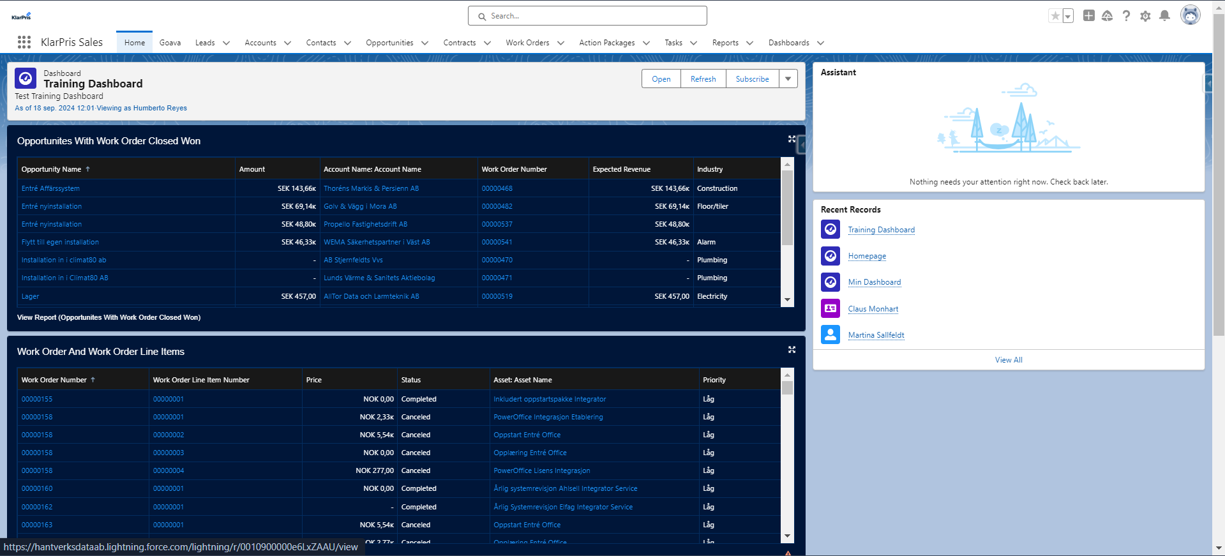

3)Pajadata Sales
https://hantverksdataab.lightning.force.com/lightning/page/home
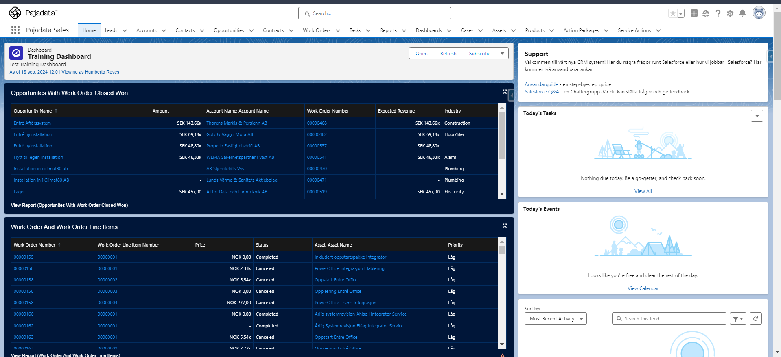
4)Rekyl Sales
https://hantverksdataab.lightning.force.com/lightning/page/home
